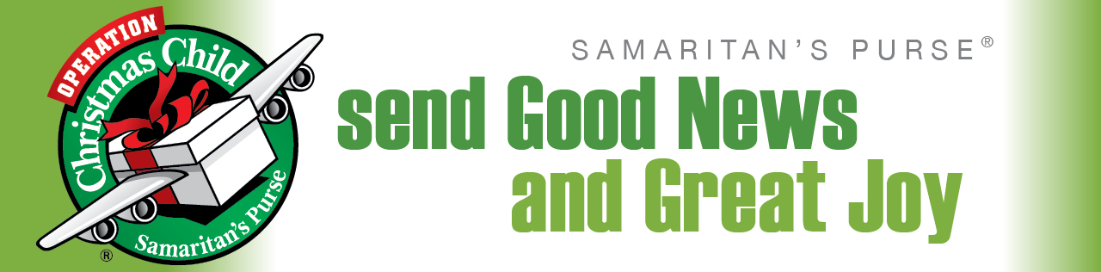
Last year, our Cornerstone family participated in this awesome ministry. By God’s great grace, we packed and delivered 63 shoeboxes! That was 63 children impacted by the gift of the Gospel! This year our goal is 75 and we can reach it with your help.
“What is Operation Christmas Child?” you ask. Operation Christmas Child (OCC) is one of the major ministry efforts of Samaritan’s Purse led by Franklin Graham. Through simple, inexpensive gifts packed in shoeboxes, over 100 million children around the world have experienced the Good News and Great Joy of Jesus Christ. Want to see what God can do through an OCC shoebox? Watch at http://www.samaritanspurse.org/operation-christmas-child/occ-stories/ .
How can you get involved? There are several ways to participate:
- Pray for God to work miracles through these shoebox gifts.
Prayer is an essential part of this process and there are many areas of this ministry to pray over: the shoeboxes, the recipients, the OCC staff, the Greatest Journey teachers, and so much more. Make OCC a prayer point during your prayer time. Prayer guides will be available on the resource table soon for your convenience.
- Collect quantities of small, new gifts that can be packed in to a shoebox at the upcoming Packing Party.
Some ideas to consider are: dolls, soccer balls (with pump), stuffed animals, yoyo’s, jump ropes, balls, toys that light up and make noise, school supplies (pens, pencils and sharpeners, crayons, markers, paper, solar calculators, coloring and picture books), non-liquid hygiene items (toothbrushes, toothpaste, bar soap, washcloths, combs), accessories (T-shirts, socks, hats, sunglasses, hair clips, jewelry, watches, flashlights), crafts (DIY items such as hair bows, finger puppets, and friendship bracelets), and don’t forget extra batteries.
- Pack a shoebox as part of your family devotion time.
Packing a shoebox (or several!) is a great family ministry project. You can even include a picture and/or letter from your family. Sometimes, you even get a response. Donate the shipping charge online at http://www.samaritanspurse.org/operation-christmas-child/follow-your-box/ and your family can track their gift to its destination. If you choose to pack your own, you can still participate in the OCC Packing Party. Just bring your filled boxes to add to the collection and stick around to help us fill more!
- Give financially, as God leads you, to assist with shipping costs and the purchase of bulk items.
It costs $7.00 per box for shipping. Considering the distance and the destination of these shoeboxes, this is a small fee. In addition to the shipping charges, we may need just a few more items to top off the shoeboxes (i.e. hard candies, gum, erasers, book marks, etc.). If you would like to contribute financially to either of these, please designate your giving accordingly.
- Participate in the OCC Packing Party. (YAY!)
On Sunday, November 15th at 5:30 p.m. we will gather for an evening of working fellowship! After enjoying a pot-luck dinner, we will take the donated and purchased bulk gift items and fill shoeboxes assembly-line style. There are jobs for young and old alike. So come one, come all to this exciting event!
- Help deliver the shoeboxes to the Myrtle Beach Drop-off location.
After the boxes are packed, we will need one or two volunteers to deliver them to one of the local area drop-off sites in Myrtle Beach.
Thank you for your prayers and support of this incredible ministry opportunity. We are anxiously waiting to see what God will do!

